Microsoft logo

Robotic Process Automation in a Day

Lab prerequisites 1.3 – Install required software

30 mins

April 2023

Applies to Power Automate Desktop v. 2.31.105.23101 ([more](https://learn.microsoft.com/en-us/power-platform/released-versions/power-automate-desktop))



This document is provided “as-is.” Information and views expressed in this document, including URL and other Internet Web site references, may change without notice. You bear the risk of  
using it. Some examples are fictitious and are for illustration only. No real association is intended  
or inferred. This document does not provide you with any legal rights to any intellectual property in any Microsoft product. You may copy and use this document for your internal reference purposes.

© 2021 Microsoft Corporation. All rights reserved.

Pre-requisite task 1.3: Install required software on your computer (required)

This lab will guide you through the steps of installation required software on your computer. That is:

1. Power Automate Desktop (PAD) and required extensions
2. Register machine
3. Contoso Invoice App

**Note:** follow the steps below if you haven’t previously installed the above software. If you have Power Automate Desktop (PAD) app already installed and machine registered, check that you are **running on the latest version of PAD**. If not, it is recommended to update to the latest, by following the installation instructions below.

**Note:** **machine requirements:** to continue be sure you log into the machine using an account with permission to install software, preferably an account with local administrator rights. The machine should have Win10 Pro OS (or Win server 2019/2016 OS), Net 4.7.2 and Edge (chromium) or Chrome installed. The machine can be a physical machine or a Virtual Machine, however we do see performance issues on slow VMs so recommend choosing a high performance VM. Check here for the full [Power Automate Desktop prerequisites & limitations - Power Automate | Microsoft Docs](https://docs.microsoft.com/en-us/power-automate/desktop-flows/setup)

## Install Power Automate Desktop application

1. Navigate to <http://make.powerautomate.com/> and sign in with the account you are using for the labs (created in labs 1.1):
2. Click My flows.

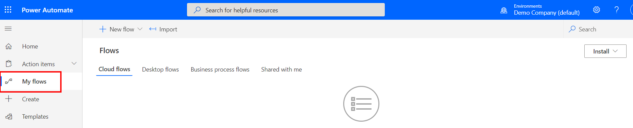

1. Click Install and select Power Automate Desktop.

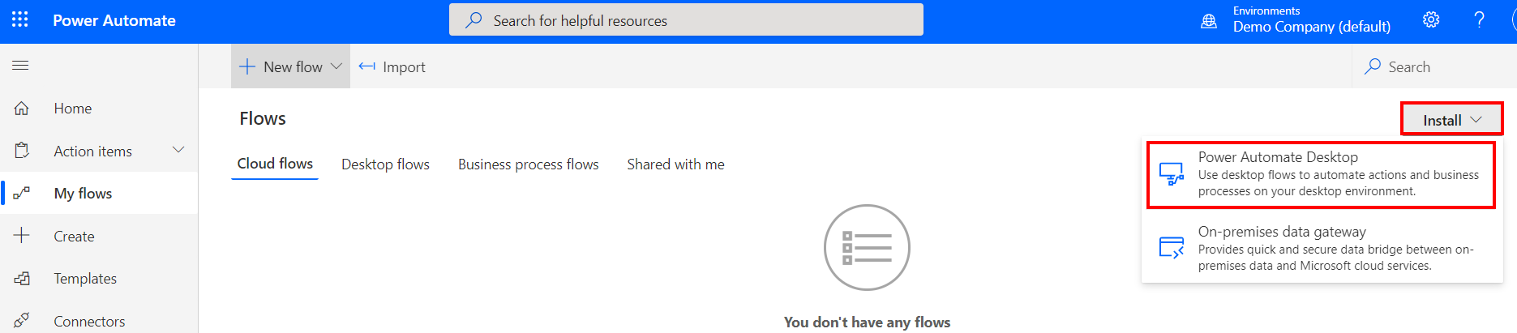

**Note**: Pay attention to the bar at the bottom of your browser where shows the downloading progress.

1. Once download completes, click on the file to open and run the installer: Setup.Microsoft.PowerAutomateDesktop.exe

UI flow app download successfully.

1. Select the following options as illustrated and click the **Next** button.

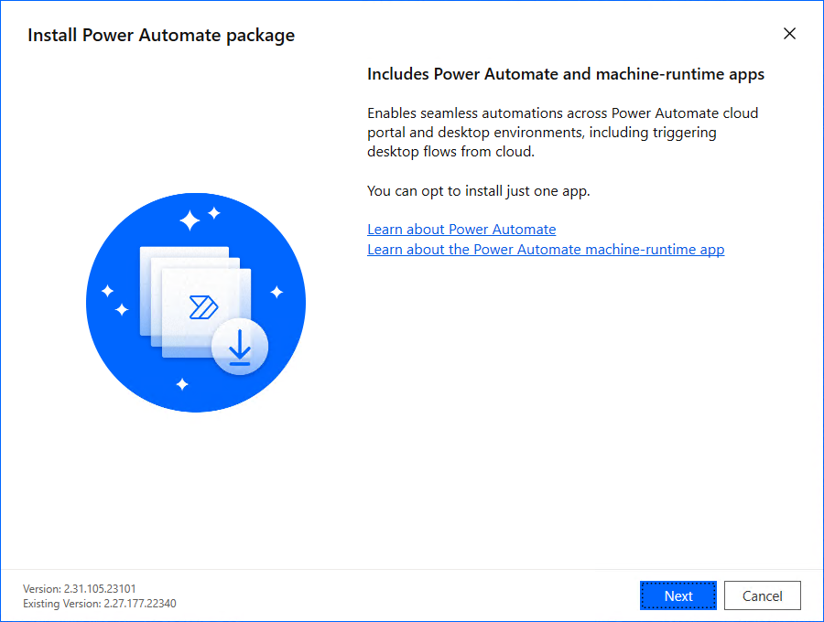

6. Select the checkbox to agree to Microsoft’s terms of use then click **Install** button

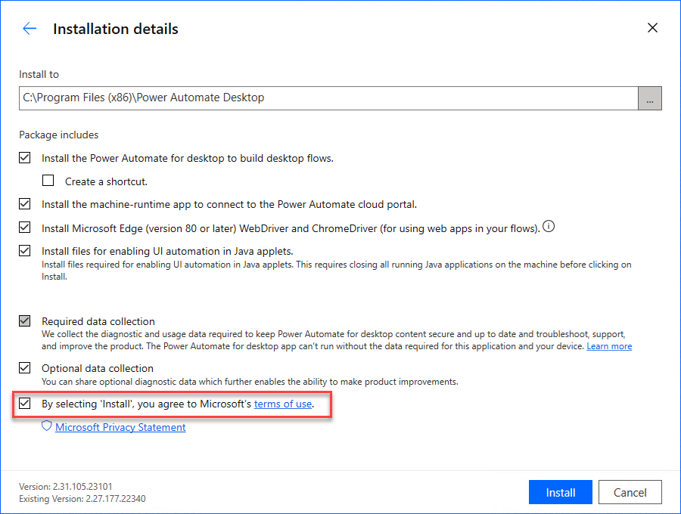

1. Installer will install on your computer:
   1. Power Automate Desktop app
   2. Power Automate Desktop browser extension for Edge Chromium and Google Chrome
   3. Power Automate machine runtime management app

**Note**: You must use local admin account to install Power Automate Desktop applications.

**Note**: Installation may take up to 10 minutes.

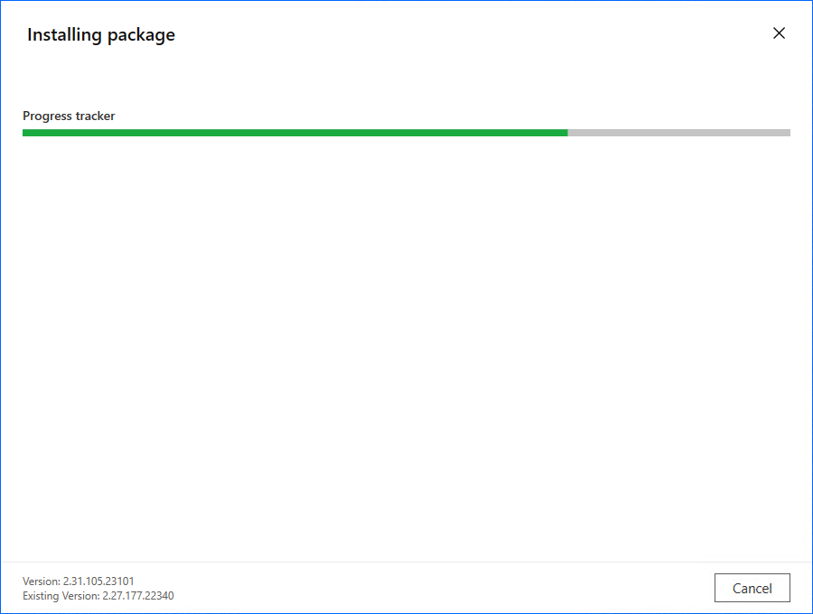

1. After installation is finished click the hyperlinks in step (1) to navigate to a chosen browser(s) to enable Power Automate Desktop extensions. After your extensions have been configured, you can launch Power Automate Desktop in step (2).

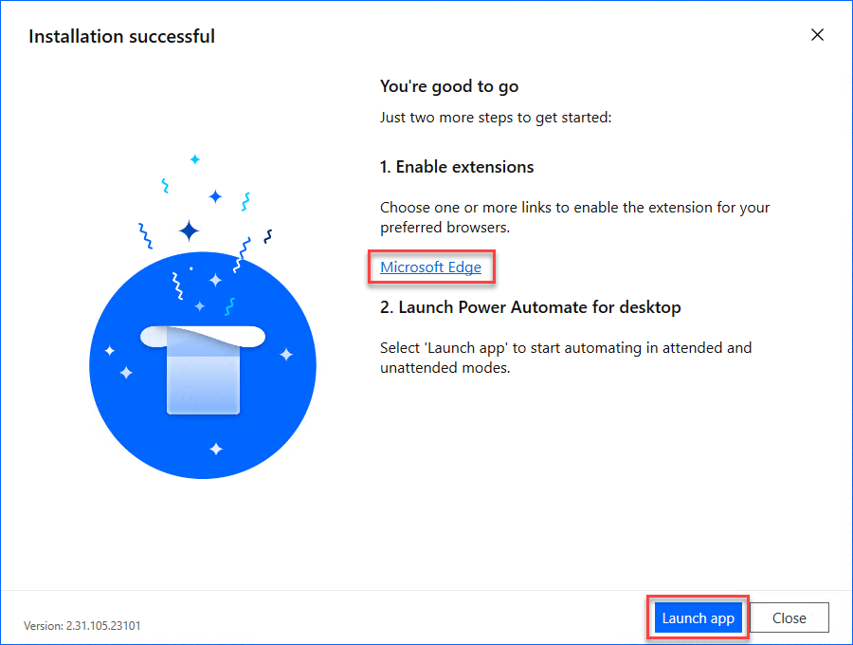



1. If you don’t see this prompt, you can still manually enable the extension. Depending on what browser you are using, please follow the steps below to confirm the extension is enabled:
   1. Enable in Microsoft Edge (Chromium)
      1. Open edge://extensions URL in the Edge (Chromium) browser
      2. Find “Microsoft Power Automate” extension.
      3. Toggle button to enable extension.

* + 1. Click Details

* + 1. Check **Allow in InPrivate** and **Allow access to file URLs** checkboxes.

* 1. Enable in Google Chrome
     1. Open chrome://extensions URL in the Chrome browser.
     2. Find “Microsoft Power Automate” extension.
     3. Toggle button to enable extension.

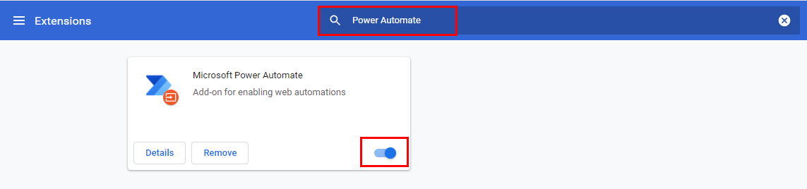

* + 1. Click Details.

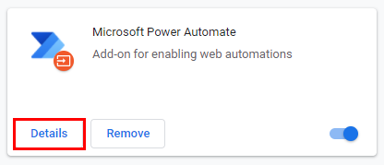

* + 1. Toggle **Allow in Incognito** button to be on

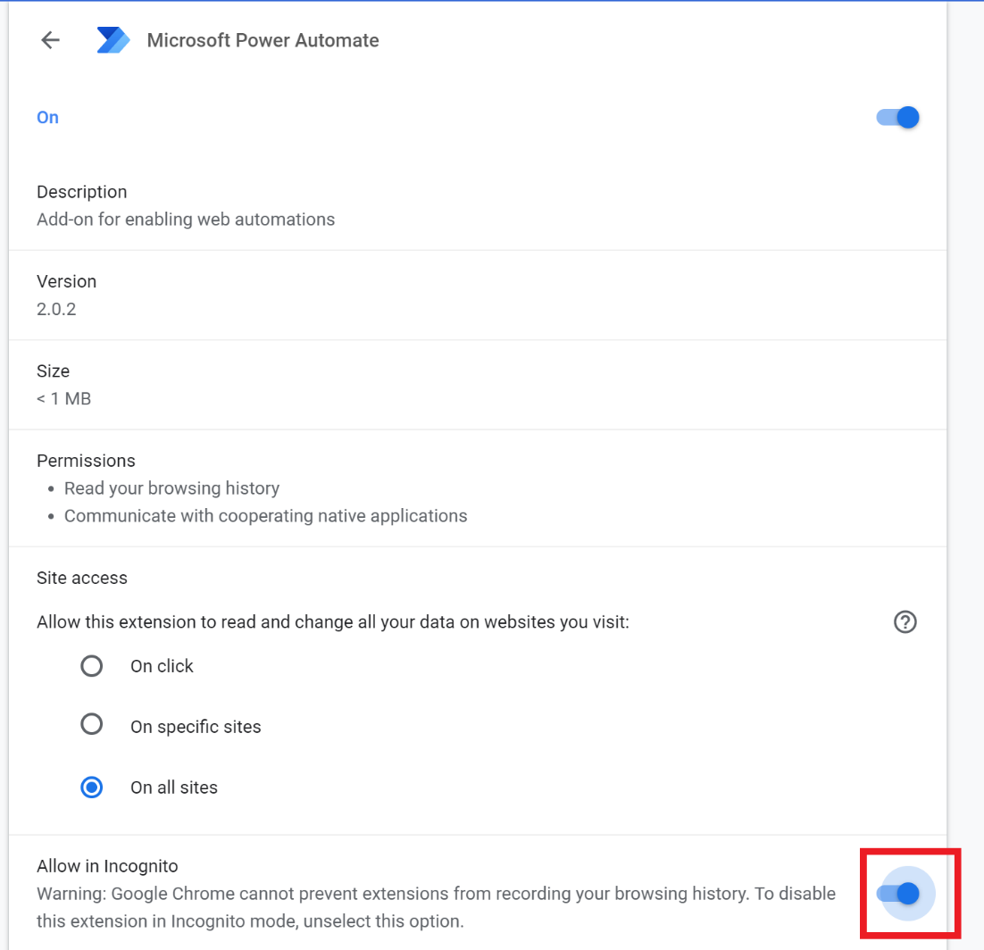

1. Next Launch Power Automate Desktop. In the opened window, click “Sign in” and use the admin account that you created in Lab 1.1 step 10:

1. If you are log in for the first time, you might see the tour window. You can either start a tour or skip

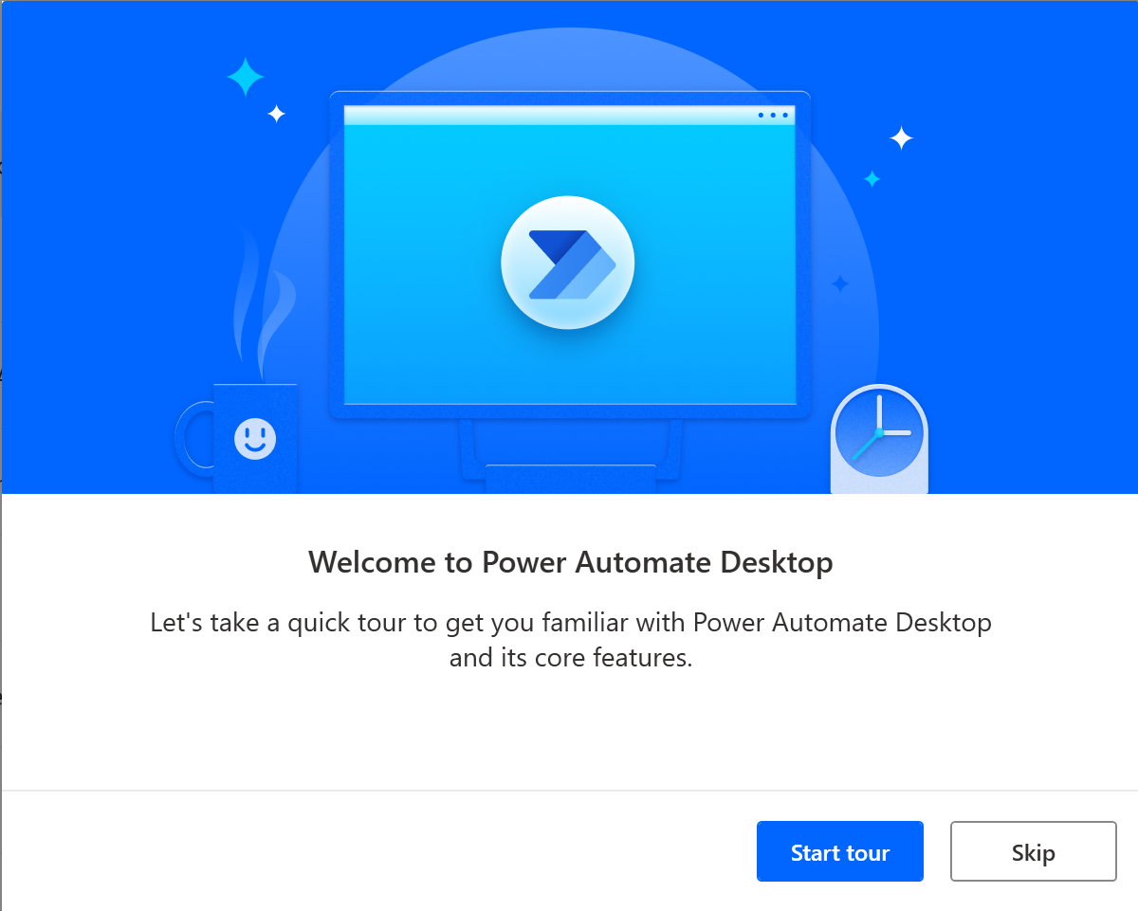

## Register machine

**Note:** If you have not previously registered your machine to another environment, then Power Automate Desktop will automatically register your machine to the default environment at the installing time, so that you don’t need to do the following steps. However, we still recommend you try to follow the steps below

1. Click Settings from Power Automate Desktop app

1. Click Open machine settings link under Machine settings

1. This will open the **Power Automate machine runtime** app

**Note:** If the machine is auto-registered for you, you will see the screens in step #15. You can skip step #14.

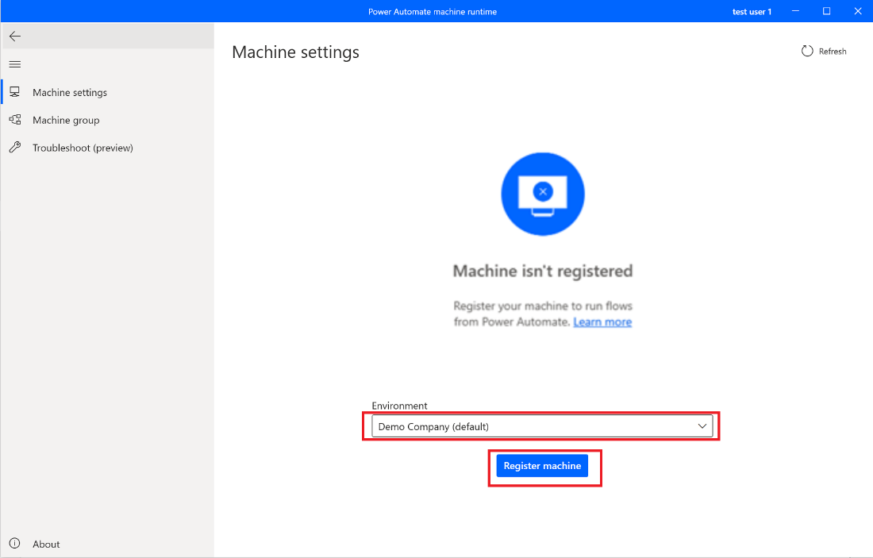

1. You can click the **Register machine** button to register this machine to the default environment. If in the future, you have multiple environments and want to register this machine to a different environment than default environment, you can use the **Environment** dropdown menu to select an environment then register. Power Automate will only allow the cloud flows in this environment to trigger any desktop flows to run on this machine.

**Important:** In order for the account to be able to register a machine it must be granted the “Desktop Flows Machine Owner” or “Environment user” environment security role: <https://docs.microsoft.com/en-us/power-automate/desktop-flows/manage-machines#update-permissions-based-on-security-role>.

1. After registering successfully, you will see this information in the machine runtime app.

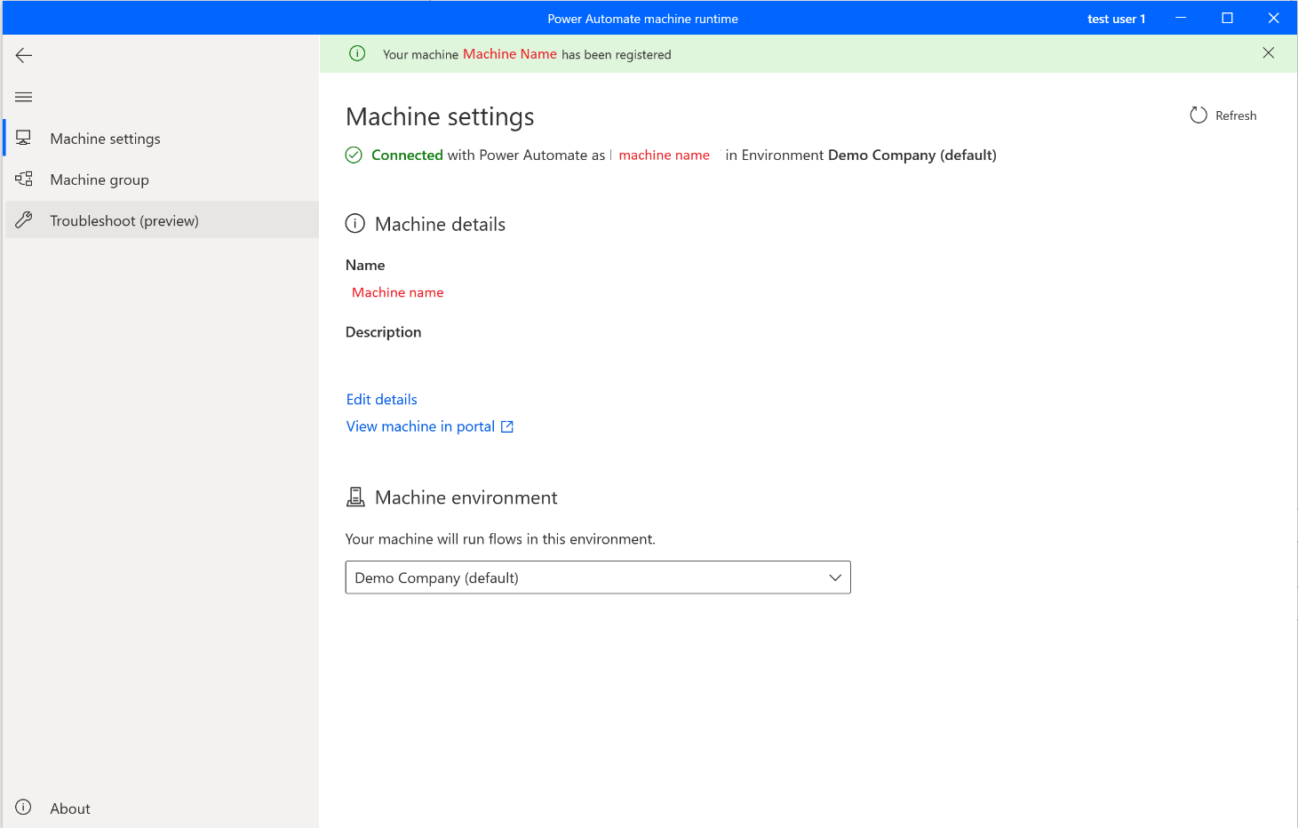

1. In the future you can also use the Machine group settings to add the machine to a machine group. You can find information about machine groups in [Manage machine groups](https://docs.microsoft.com/en-us/power-automate/desktop-flows/manage-machine-groups)

**Note:** Users will need either be an Environment Maker or desktop Flow Machine Owner role to register machines. Before registering a machine, make sure that you have the required permissions, and there is an available environment to register the new machine to.

## Install Contoso Invoice App (for labs to use)

1. Download and install both the ContosoInvoicingSetup.exe and ContosoInvoicingSetup.msi in the prerequisite #1.3 folder of **lab data packages**.

**Note:** you will need to click “More Information” and “Run it anyway” during installation of the Contoso app if Windows Defender prompts you that the app is coming from untrusted source.

1. Launch the Contoso Invoicing app from the Start menu
2. Right click and pin the app icon to task bar for quick launch. We will use this app for both the Process advisor and Robotic Processing Automation recordings.

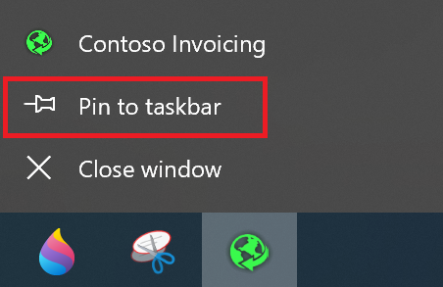

1. Now we can get familiar with Contoso Invoicing App so we can better prepare for the following lab recording exercises
   * 1. Open Contoso Invoicing App
     2. Click Invoices

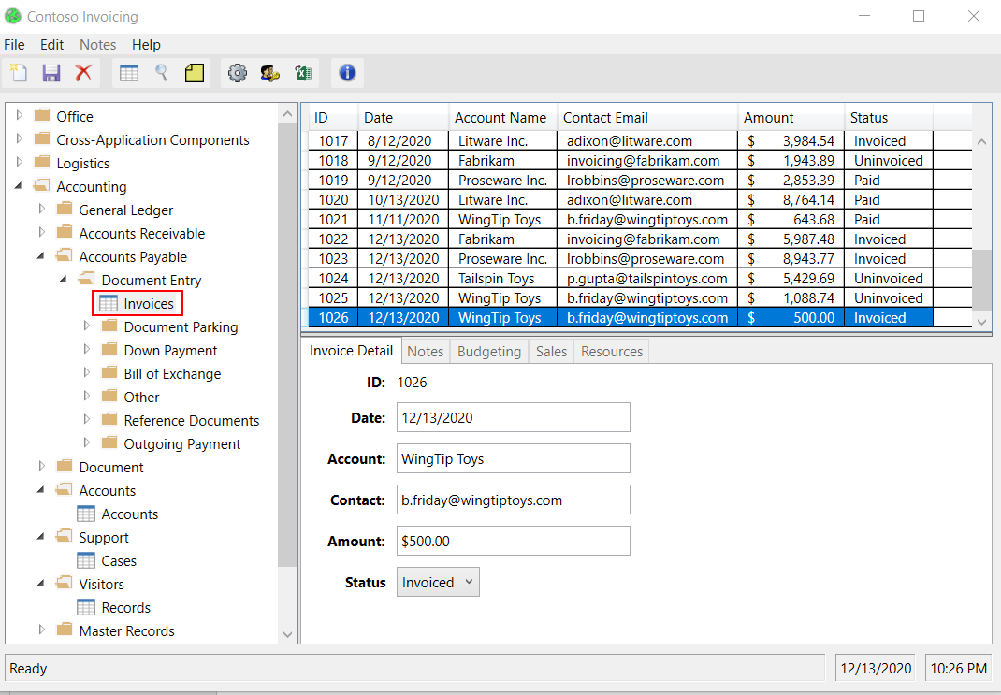

* + 1. Click New record button on the left to create a new invoice

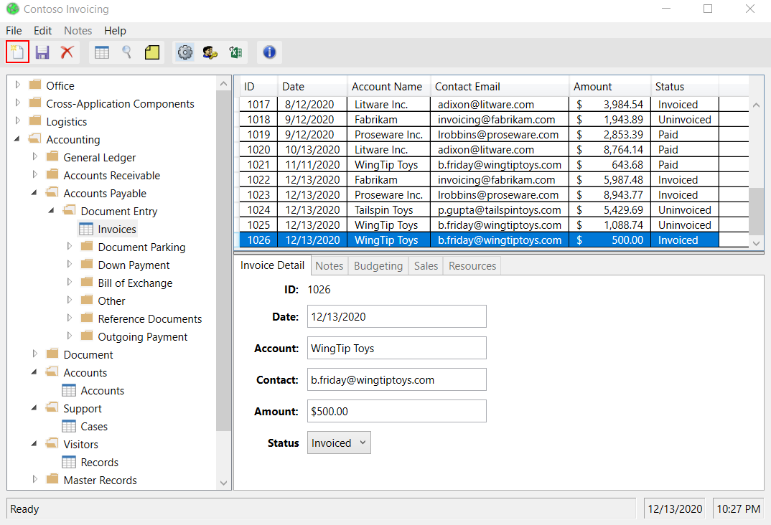

* + 1. You can fill in any information for the new invoice in the text boxes

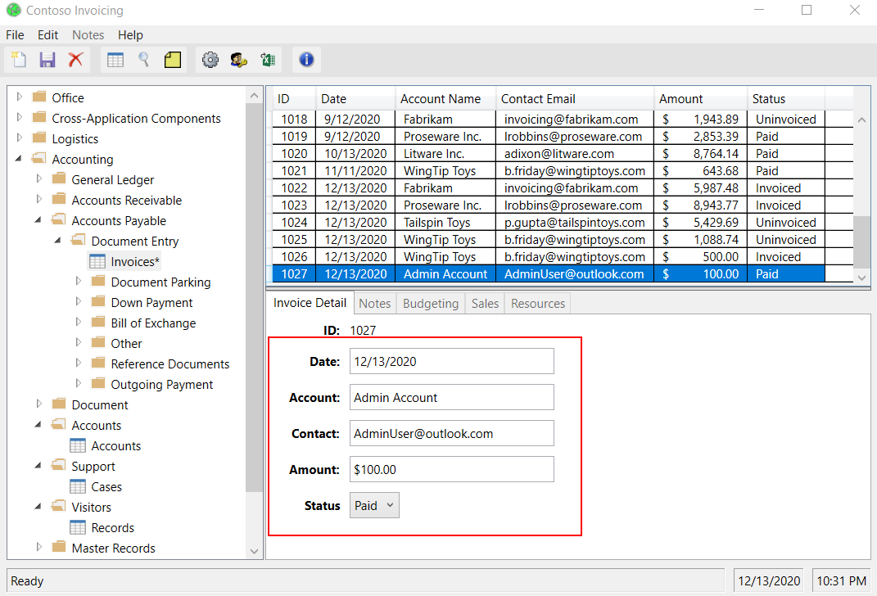

* + 1. Click Save button on the left to save your new invoice

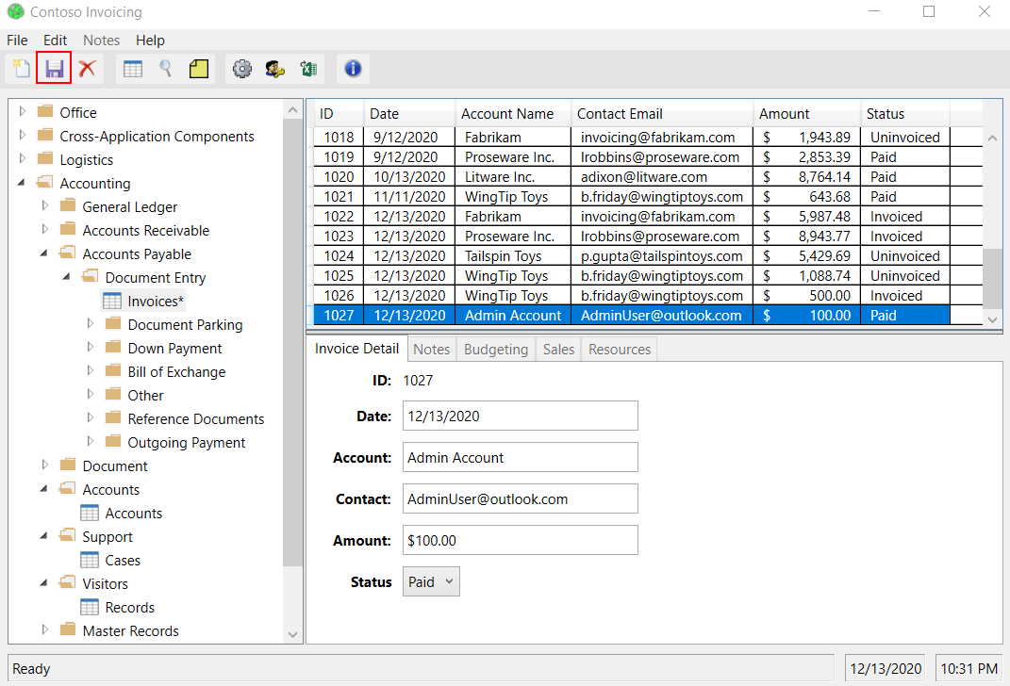

That completes the pre-requisites. You are now ready for the labs.

Information in this document, including URL and other Internet Web site references,  
is subject to change without notice. Unless otherwise noted, the example companies, organizations, products, domain names, e-mail addresses, logos, people, places, and events depicted herein are fictitious, and no association with any real company, organization, product, domain name, e-mail address, logo, person, place or event is intended or should be inferred. Complying with all applicable copyright laws is the responsibility of the user. Without limiting the rights under copyright, no part of this document may be reproduced, stored in or introduced into a retrieval system, or transmitted in any form or by any means (electronic, mechanical, photocopying, recording, or otherwise), or for any purpose, without the express written permission of Microsoft Corporation.

Microsoft may have patents, patent applications, trademarks, copyrights, or other intellectual property rights covering subject matter in this document. Except as expressly provided in any written license agreement from Microsoft, the furnishing of this document does not give you any license to these patents, trademarks, copyrights, or other intellectual property.

The names of manufacturers, products, or URLs are provided for informational purposes only and Microsoft makes no representations or warranties, either expressed, implied, or statutory, regarding these manufacturers or the use of the products with any Microsoft technologies.  
The inclusion of a manufacturer or product does not imply endorsement of Microsoft of the manufacturer or product. Links may be provided to third party sites. Such sites are not under the control of Microsoft and Microsoft is not responsible for the contents of any linked site or any link contained in a linked site, or any changes or updates to such sites. Microsoft is not responsible for webcasting or any other form of transmission received from any linked site. Microsoft is providing these links to you only as a convenience, and the inclusion of any link does not imply endorsement of Microsoft of the site or the products contained therein.

© 2021 Microsoft Corporation. All rights reserved.

Microsoft and the trademarks listed at <https://www.microsoft.com/enus/legal/intellectualproperty/Trademarks/Usage/General.aspx>are trademarks of the Microsoft group of companies. All other trademarks are property of their respective owners.